PREPARATION AND MAINTENANCE OF ZOHO BOOKS

DREAM HOMES REALTY

1.1 INTRODUTION:

Dream home is a place that meets – if not exceeds – your every need, and even needs that you didn't know you had. It reflects your personal style, and fills you with a sense of calm. Students are to find their dream-house and design the layout including amenities and price. Students then research and find a house on the market that most closely matches their design and compares the actual price and amenities to practice purchasing a home concepts.

1.2PURPOSES:

* The “Dream House” was designed with primary aim to materialize its owner's dream. A dream of a home that will not only fulfill his functional needs and accommodate his family, but also will satisfy his deepest desires, even those rising from his subconscious
* Home is where love, hope, and dreams begin. Given that most people start their own families after moving into their own house, having a new home will be a fresh start for you in more ways than one. It is a sense of accomplishment, satisfaction, and pride
* An ideal home is one that needs little maintenance and is sturdy enough to last a lifetime. Well-designed spaces that are optimised to offer maximum utility should be preferred. The architecture, spatial planning and master planning of the layout should be accommodative of your family's needs in the long run

2.1 2 PROBLEM DEFINITION & DESIGN THINKING:

EMPATHY: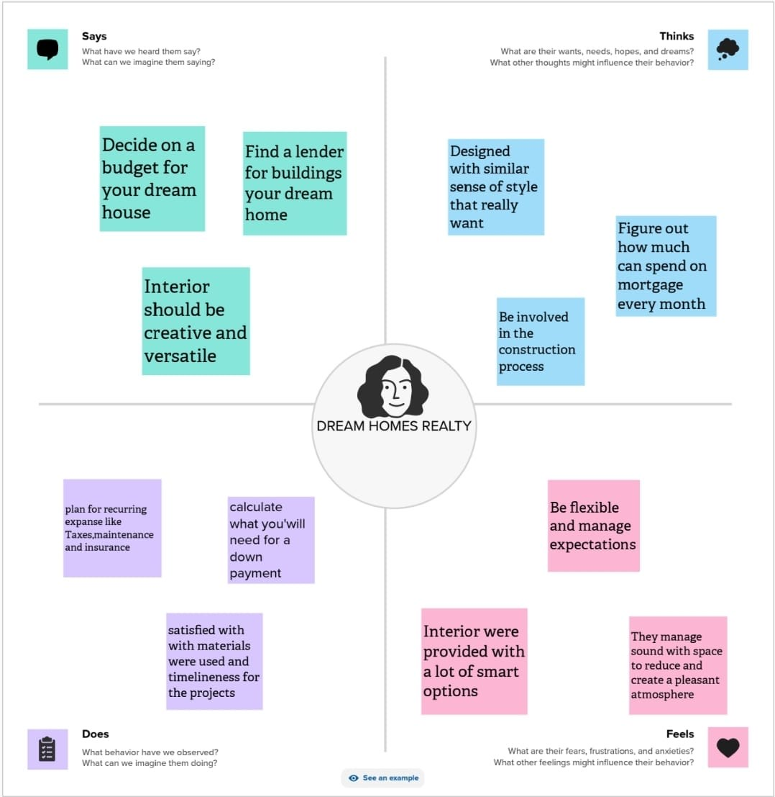

2.2 IDEATION & BRAINSTROMING MAP: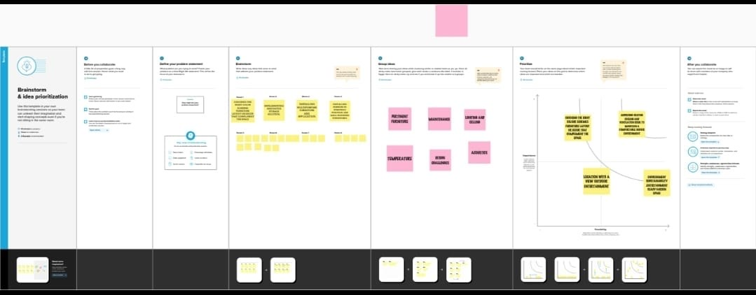

1. RESULT:

* The size of the home should be based on your budget, number of family members.
* Builders charge higher rates for apartments on higher floors in high rise buildings.
* Decide the type of home you need - apartment, independent house etc.

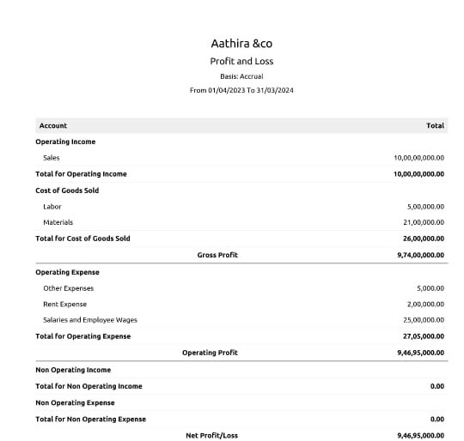

BALANCE SHEET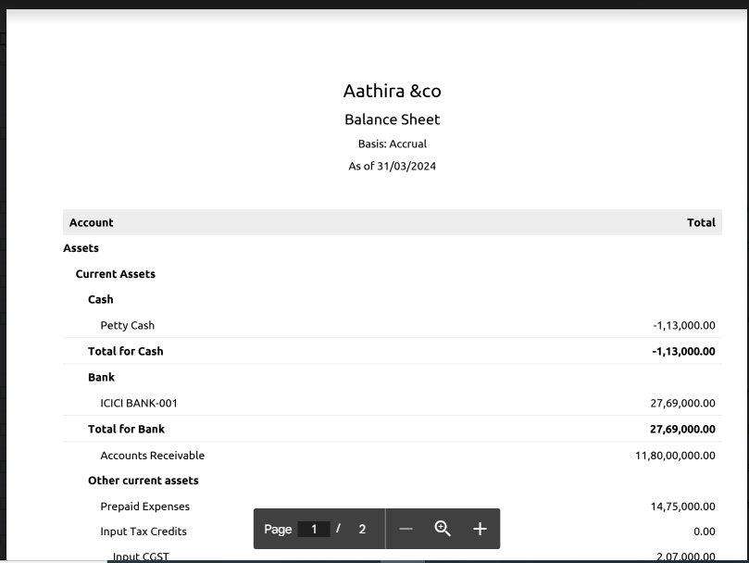

ADVANTAGES AND DISADVANTAGES:

ADVATAGES:

1. Know thyself. Understand the type of home that suits your personality. ...
2. Research before you look. ...
3. Get your finances in order. ...
4. Set a moving timeline. ...
5. Think long term. ...
6. Work with a REALTOR® ...
7. Be realistic. ...
8. Limit the opinions you solicit.

* DISADVANTAGES: The disadvantages of owning a home mostly fall into the category of permanence, with a dash of financial uncertainty. Buying a new house costs money, and a lot of that money comes out of your pocket at the time of the purchase. Later, there are no guarantees that home prices will rise.
* Real estate can also have its disadvantages including: Time-consuming if you plan to rent or sell properties. Real estate isn't a liquid asset, so you will not be able to turn into cash easily in an emergency. Dealing with rental tenants and maintenance issue
* When purchasing a villa, check for options for customization. You may have to compromise on certain features and amenities to accommodate your budget. Maintenance Costs: Villas come with additional maintenance costs such as repairs, upkeep, and renovations.
  + APPLICATION:
* This method of zoho book solutions applied to dream homes realty
* The homes suitable and near by lake view
* This may suitable for project dream homes realty
  + conclution:
* The zoho book for dream homes realty is elegent to use.
* This way very easy to apply transcation on zoho book
* It was clearly understandable for making project for Dream homes Realty.

7FUTURE SCOPE: In zoho book the preparation and maintence of zoho book dream homes realty is very useful.

It helps in ever recordings of debit and credit notes as well as creadit for dream homes journal book of record.